**File Organizer**

Final Report

November 15, 2016

Yogendra Kumar (14CA88)

Submitted in partial fulfilment of

the requirements of Computer Applications Lab

Instructor: **Dr. Anand R.**



**National Institute of Technology Karnataka**

Department of M.A.C.S.

Surathkal, Mangalore, India

**DECLARATION**

I hereby declare that the final project report entitled **File Organizer** which is being submitted to the National Institute of Technology Karnataka, Surathkal, in partial fulfillment of the requirements for Computer Applications Lab of Master of Computer Applications(MCA) in the Department of Mathematical and Computational Sciences(MACS), is a bonafide report of the work done by **Seiborlang Marbaniang**. The material contained in this project has not been submitted to any university or institution for the award of any degree.

**Name: Seiborlang Marbaniang**

**Roll No.: 14CA66**

**Place: Surathkal**

**Date: November 15, 2016**

**CERTIFICATE**

This is to certify that the project report entitled **File Organizer** submitted by **Seiborlang Marbaniang (14CA66)**,as the record of the work carried out by him is accepted as the research thesis submission in partial fulfillment of the requirements for the award of degree **Master of Computer Applications(MCA)** in the Department of **Mathematical and Computational Sciences(MACS)**.

**Dr. Anand R.**

(Signature with date and seal)

**ACKNOWLEDGEMENT**

I like to thank many people who helped us in completing this project. Foremost I would like to thank **Dr. Anand R.** sir for giving me the strength and the ability to complete this project. I would like to express my gratitude to all those who gave me the possibility to complete this project and I want to thank the Department of **Mathematical and Computational Sciences(MACS)** for helping me to do the necessary research. I furthermore, thank my project teacher **Dr. Anand R.** for giving me complete support and advising me in the project. Especially, we would like to thank our colleagues for the valuable suggestions.

**ABSTRACT**

File Organizer is an android application. The main aim of this application is that it organize files of similar types into a particular folder, for e.g. A jpeg or png files will be moved to the Images folder , mp3 files will be move to the Music folder and so on with Videos and Documents files. The Application also have the ability to creates sub folder, that is if a video file say was found within a Whatsapp folder while File Organizer is scanning, on moving the video files to the Videos folder File Organizer will create a sub folder within the videos folder with the name being Whatsapp.

**CONTENTS**

|  |  |
| --- | --- |
| **Title** | **Page no.** |
| Abstract | 5 |
| Chapter 1: Introduction | 7 |
| Chapter 2: System Study | 8 |
| Chapter 3: Process | 9 |
| Chapter 4: System Specifications | 10 |
| Chapter 5: Screenshots | 11 |
| References | 16 |

**CHAPTER I**

**INTRODUCTION**

The project **File Organizer** is being developed using one of the most popular and widely used Android development IDE, Android Studio. The project uses Java as its base programming language to solve the problem combined with XML to help design the UI of the application.

The application will provide an interface such that a user will be able to organize image files, audio files, videos files and documents files with his or her phone.

**CHAPTER II**

**SYSTEM STUDY**

System study aims at establishing requests for the system to be acquired, development and installed. It involves studying and analyzing the ways of an organization currently processing the data to produce information. Analyzing the problem thoroughly forms the vital part of the system study. In system analysis, prevailing situation of problem is carefully examined by breaking them into sub problems. Problematic areas are identified and information is collected. Data gathering is essential to any analysis of requests. It is necessary that this analysis familiarizes the designer with objectives, activities and the function of the organization in which the system is to be implemented.

1. **Existing System**

None

1. **Proposed System**

The proposed system organizes files of similar types into a particular folder, for e.g. A jpeg or png files will be moved to the Images folder within your storage. The app will scan the whole storage area of the phone for picture, videos, documents, music files once everything is done it will move all the files from different location in to one.

**CHAPTER III**

**PROCESS**

1. **Creating Images, Music, Documents, Videos Folder**

This process is called when the application is open. The application scan the whole internal storage and check whether folders with the names Images, Music, Documents and Videos have been created or not. If the folders are not available then File Organizer create the necessary folder. If the folder are available then File Organizer will not create or replace the existing folders.

1. **Scanning**

File Organizer comes with the option of which files to search for if the user want to search only documents files he can do so. Scanning was possible with the help of **Java IO package**. The scanning of files scan the whole internal storage but leaves the system folder so as it does not affect other applications.

1. **Creating Sub Folders**

After the scanning process, File Organizer acquires the folder names for each files and creates all the required folders before moving the files to their respective folder. If the folder already exist the

1. **Moving Files**

File Organizer first checks each file to which folder it’s going to move. Then it moves them accordingly. The Moving process was made possible using **Apache Common IO api**.

For **Android Lollipop** and below, the process was done normally.

For Android Marshmallow and above permission will be ask in order for File Organizer to work.

**CHAPTER IV**

**SYSTEM SPECIFICATIONS**

**Platform:** Android

**Version Code:** 4.1

**Version Name:** Jelly Bean

**RAM:** 1GB

**Permission:** Write Permission required

**CHAPTER V**

**SCREENSHOTS**

1. **Splash Screen**

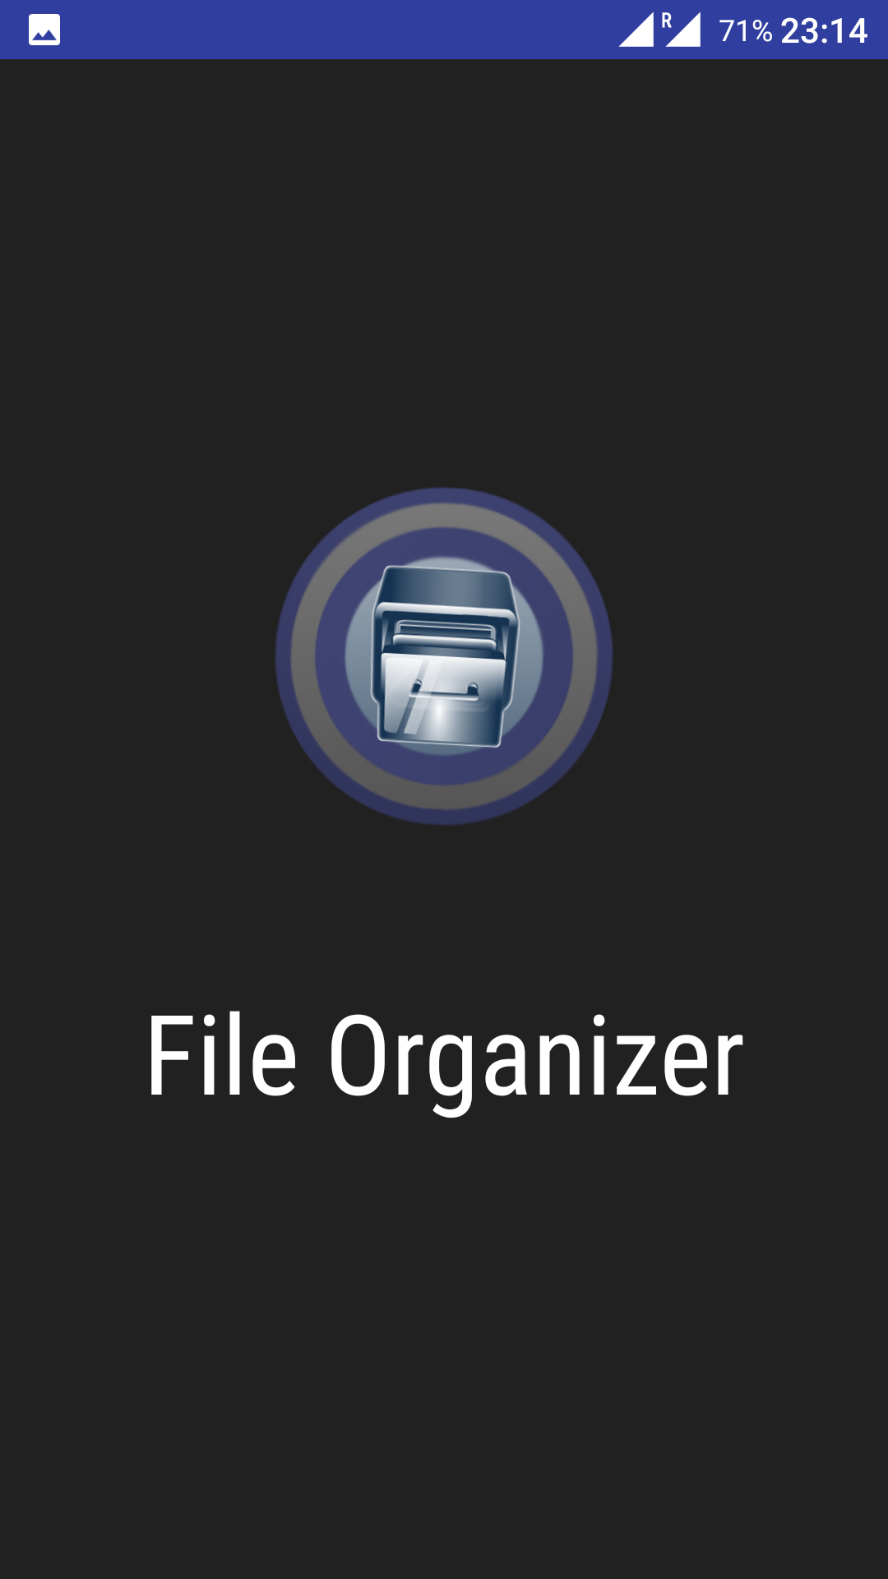

1. **Main Screen**

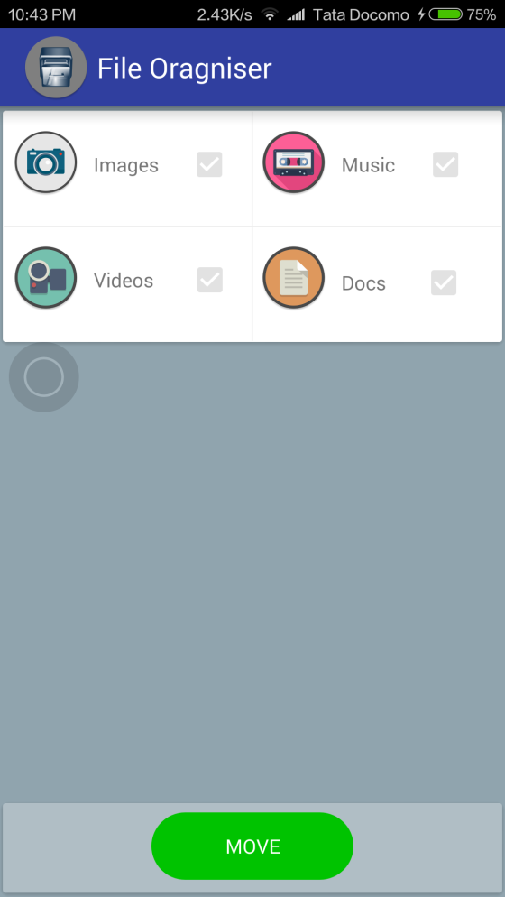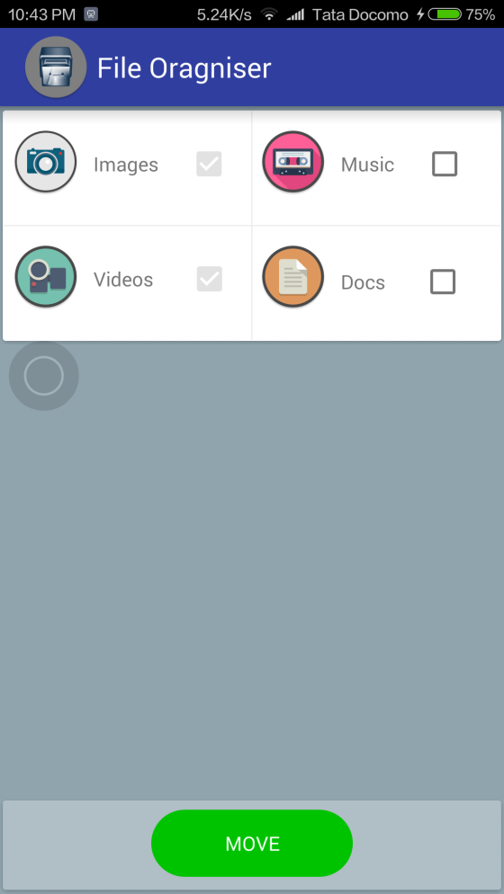

1. **Moving**

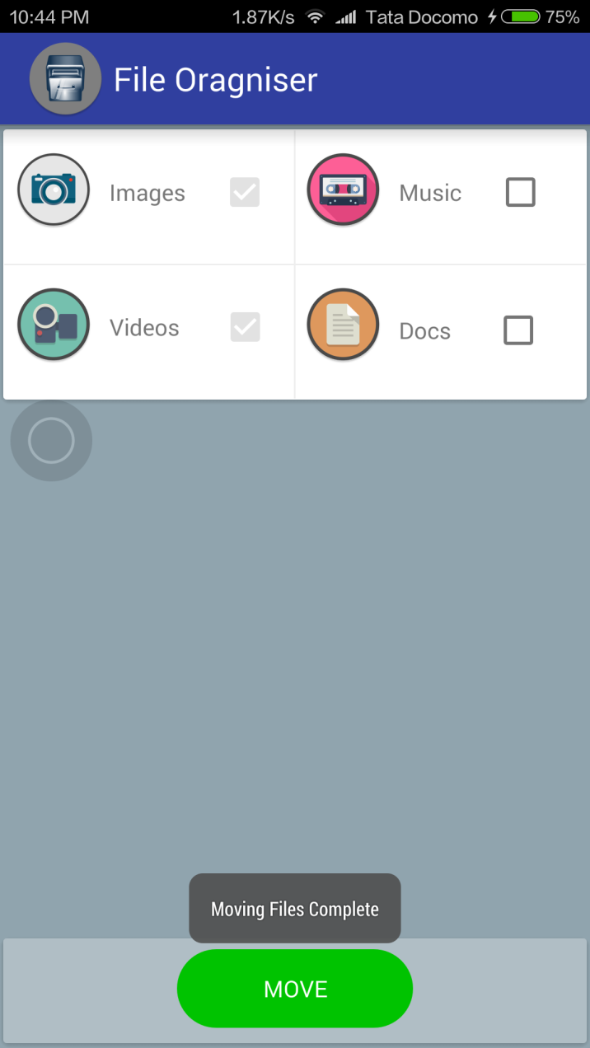

1. **Before Moving**

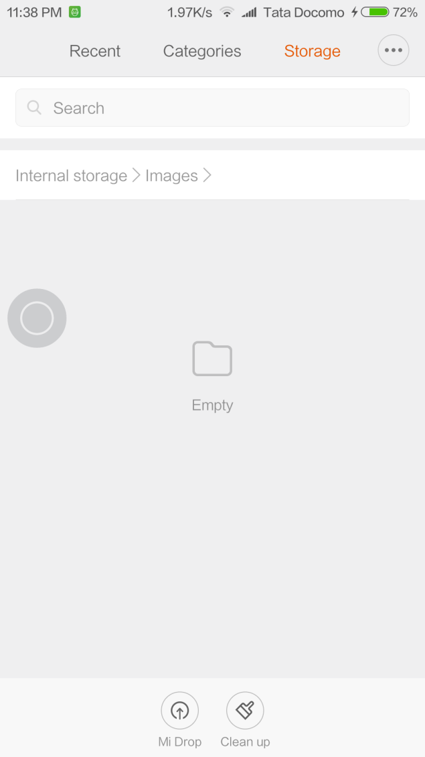

1. **After Moving**

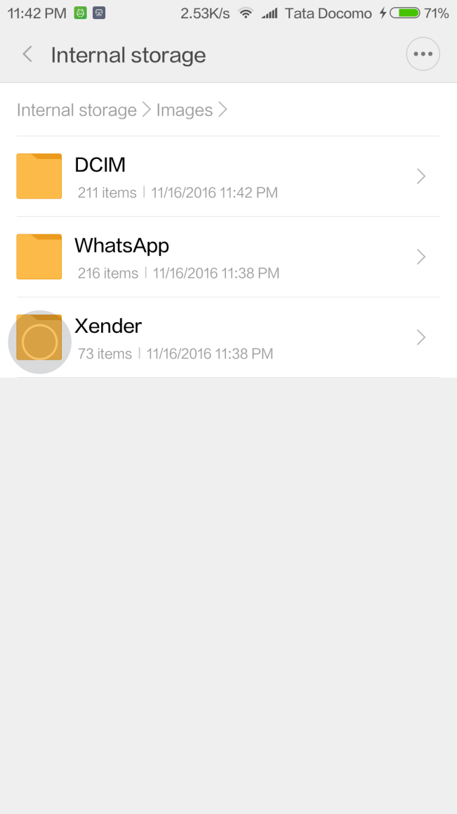

**REFERENCES**

* <http://stackoverflow.com/>
* <https://android-arsenal.com/>
* <https://youtube.com/>
* <https://developer.android.com>